CONSTITUTION OF HOWGATE COMMUNITY COUNCIL
Adopted at the Howgate Community Council AGM of 21 June 2018

- The Council means Howgate Community Council (“the Council”)

- Objectives of the Council:

  - To promote the wellbeing and foster community spirit of the members of Howgate and District (see Appendix 1 for map of the area)( the “HCC area”).

  - To ascertain, co-ordinate and express the views of the community to the appropriate authorities in the area and to communicate with Midlothian Council or its successor body.

  - In seeking to meet these objectives, all Council meetings will normally be open to the public. Sensitive issues may be discussed in private if approved by a majority of members. The public will be informed of any such issues in advance.

- The Council shall be non-political and non-sectarian.

- The Council

  - The Council shall consist of up to 7 elected members

  - The rules and mechanism for election to and serving on the Council will be those set out in Appendix 2. Members of the community eligible for election to the Council must be age 16 and over, reside in the HCC area and be named on the electoral register for the community area. The process for nomination will be that described in Appendix 2.

4.3 If at any time the aggregate of serving members as referred to in Clause 4.5 and those nominated for election is less than 4 no community council shall be established at that time.

  - Members of the community eligible to vote must be age 16 and over, reside in the HCC area and be registered on the current register of electors as referred to in Clause 9.1 of appendix 2

  - Membership of the Council shall be for 3 years. Retiring members shall be eligible for re-election. Normally no member no member may serve more than 6 years on the Council without a break of 1 year.

  - Three members of the Council are required to form a quorum.

  - Should a vacancy or vacancies arise between elections, the provisions of Clause 9.2.2.3 of Appendix 2 will apply.

  - The Council shall normally meet a minimum of 6 times per annum and all members of the community are eligible to attend these meetings.

  - The Chair of the Council shall normally preside at all meetings and has a casting vote. In the absence of the Chair an Acting Chair may be approved by the members attending a meeting.

  - If any member of the Council has a conflict of interest in relation to any topic to be discussed at a meeting that member shall declare an interest and the chair will be entitled to decide whether that member should or should not be entitled to vote on that issue but nothing shall prevent any member from participating in discussions in relation to any issue whether or not a conflict of interest has been declared

  - After the minutes of a meeting have been approved at a subsequent meeting of the Council, a copy will be provided to the appointed Midlothian Council Liaison Officer.

  - Where Midlothian Council have appointed a Midlothian council Liason Officer to develop a working relationship, consultative mechanism and strategy for greater involvement with and a working relationship with the Council, the Council will give the Liason Officer such information as they may reasonably require to enable them to perform their role effectively.

  - The Council will inform the members of the HCC area of its work and decisions through the village website and other suitable communication channels

5. The Annual General Meeting (AGM) shall be held no later than the 30th June each year. The community shall be given at least 14 days’ notice of the AGM by appropriate means, including dissemination on any appropriate website..
6. The Council shall have the power to:
6.1 Elect its own office bearers who shall consist of the Chair, Secretary and Treasurer.
6.2 Apply to Midlothian Council for funding and investigate other methods of financing.
6.3 Set up appropriate sub-committees, co-opting expertise if deemed necessary.
6.4 Liaise with, and collaborate with, other local groups with aims that accord with those in Clause 2 above.
6.5 Liaise with other community councils with regard to matters of mutual interest.
7. Council monies
7.1 Funds of the Council shall be used to further the objectives as detailed in Clause 2 above.
7.2 The Treasurer of the Council shall keep accounts. These shall be audited by a person who is not a member of the Council and shall be presented at the AGM.
7.3 All monies shall be paid into an account in the name of the Council at a bank in Penicuik. Withdrawals shall be made with the signatures of any 2 of the office bearers. Authorised signatories may not be cohabitees.
7.4 The financial year shall end on the 31st March in each year.
7.5 A copy of the annual accounts, after approval at the AGM, shall be sent to the appropriate officer at Midlothian Council.
8. The constitution may be amended at an AGM or Special General Meeting (SGM) subject to the ratification of Midlothian Council. Any proposal by the Council to alter this Constitution must first first be considered by a meeting of the Council and the terms of the proposal to alter the Constitution shall be stated on the notice calling the meeting which shall be issued not less than ten days prior to the meeting. Any proposed alterations may not prejudice the terms and objectives contained within the Scheme for the Establishment of Community Councils.
If the proposal is supported by two-thirds of the total voting membership of the council and is approved in writing by the local authority , the alteration shall be deemed to have been duly authorised and can then come into effect.
9. The Council may call a SGM at any time subject to14 days’ notice and it must do so within 14 days of being requested in writing by at least 20 members of the community.
10. Dissolution of the Council
10.1 Dissolution can only take place at a SGM called for the purpose, provided notice has been in writing to the community and to Midlothian Council.
10.2 The Council can only be dissolved by resolution carried by not less than two-thirds of the total voting membership at such meeting and is approved by the local authority
10.3 Funds held in the name of the Council at the time of any dissolution shall be applied to any purpose for the benefits of the inhabitants of the Howgate area, as determined by the Council, agreed at the dissolution meeting and approved by Midlothian Council.
.
Appendix 1 – Howgate area
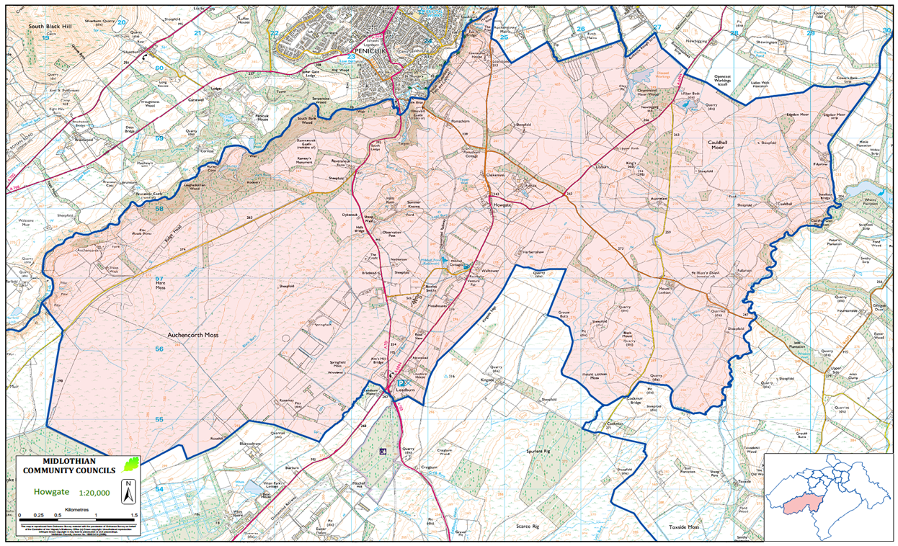

Appendix 2 Extract from “The Scheme for Community Councils in Midlothian, 2013”
9 Community Council Elections

9.1 Eligibility
Candidates aged 18 and over wishing to stand for election to a community council must reside in the Community Council area and be named on the Electoral Register for that area. The same criteria shall apply to voters in a Community Council election.
16 and 17 year-olds residing in the community council area and named on the Electoral Register for that area are also entitled to both stand for the community council and vote in any election. In the case of candidates who are not on the electoral register solely by reason of age, the nomination form must be accompanied by a declaration, signed by 2 individuals who are named on the electoral register for the relevant community council area in which they reside, confirming that the nominee is a resident of the same Community Council area.
Any community council member who no longer resides within that community council area is deemed to have resigned from that community council.
Any individual who is elected to serve on Midlothian Council, or the Scottish, UK or European parliament shall be ineligible to remain a community councillor, or to stand for election to a community council. Such persons, upon taking office, become ex-officio members of the community councils contained in whole or in part of their electoral constituency.

Any individual who is either the subject of bankruptcy proceedings or who during the five years prior to the date of nomination has been sentenced to a custodial sentence longer than three months shall be ineligible to stand or remain as a Community Councillor.

9.2 Nominations and Elections Within 3 years of the adoption of this scheme by Midlothian Council, Community Councils must both make any necessary updates to their Community Council Constitution and then hold the first elections under the Scheme. Subsequent elections will be held in accordance with the Constitution of the Community Council, with the proviso that Community Councillors shall serve for a maximum period of 3 years before being required to retire but shall be eligible for re-election. Elections shall be organised by the Community Council, with support and guidance from the Liaison Officer.

9.2.1 Returning Officer
The local authority will appoint an Independent Returning Officer. The Independent Returning Officer shall be either an Elected Member or a member of Midlothian Council Staff. The Independent Returning Officer must not be a current elected member of that community council nor intending to stand for election to that community council.

9.2.2 Nominations
Individuals seeking election to a community council require to be nominated by a proposer and seconder, both of whom must be on the Electoral Register for that community council area. Nominations require to be submitted with the candidate’s consent. Self-nomination is not permitted.
A nomination form should be completed, the style of which is defined in Appendix E Nomination form, a copy of which is annexed hereto or its successor document from time to time. Nomination forms require to be submitted to the contact for that Community Council, identified on the Midlothian Council website, no later than 5pm. 7 days prior to the date of the election. No nomination forms submitted after that date will be accepted.

9.2.2.1 Process
On the expiry of the period for lodging nominations:
a) Should the number of candidates validly nominated equal or exceed HALF, but be less than or equal to the total maximum permitted membership as specified in the Constitution for the community council area, the said candidates will be declared to be elected and no vote shall be held.
b) Should the number of candidates validly nominated exceed the total maximum permitted membership as specified in the Constitution for the community council area, arrangements for an Election shall be implemented. At the Election, each voter shall be entitled to vote for candidates up to the number of vacancies on the community council.
c) Should the aggregate of the serving members who period of office will not cease at the relevant meeting and the number of candidates to be elected be below HALF of the total maximum permitted membership, as specified for the community council area, no community council will be established at that time. However, that does not preclude the local authority from issuing a second call for nominations for a community council area failing to meet the minimum membership.

9.2.2.2 Method of Election
Community councils shall be elected on a simple majority basis. The preferred method of election is using a show of hands at a Public Meeting by those entitled to vote, however where appropriate an alternative method can be approved by the Returning Officer.

9.2.2.3 Filling of casual places/vacancies between elections
Casual vacancies on a community council may arise in the following circumstances:
• When an elected community council member submits her/his resignation;
• When an elected community council member ceases to be resident within that community council area;
• When an elected community council member has her/his membership disqualified (see 11 Disqualification of Membership).
Should a vacancy or vacancies arise in a community council between elections, it shall be a requirement that the community council undertake appropriate election/co-option arrangements, in consultation with the local authority. Under certain circumstances, a Community Council may decide not to fill a Casual Vacancy, provided the membership will not fall below HALF the membership defined by the Community Council’s Constitution. Filling a vacancy can be undertaken either through the process of an interim election or by co-option. However, should circumstances arise that lead to the number of elected community councillors falling below HALF of the membership defined by the Community Council’s Constitution, the Midlothian Council shall be informed and shall undertake arrangements for an interim election to be held.
9.2.2.4 Co-option to Community Councils
Co-opted members must be eligible for membership of the community council as detailed in 9.1 Eligibility. They must be elected onto the community council by a simple majority of the elected (general and interim) community councillors present and voting. Such co-opted members shall have full voting rights, with the exception of voting on co-option of members, and will serve until the next round of elections (general and interim). Notice of any proposed co-option procedure is required to be intimated to all of that community council’s members at least 14 days prior to the meeting when the matter will be decided.
The number of co-opted members may not exceed a THIRD of the current elected (general and interim) community council membership. Should the ratio of coopted to elected community councillors become greater than one third, due to any circumstances, an interim election process shall be triggered.

9.2.3 Additional Membership

9.2.3.1 Associate Members
Associate members may be appointed by a community council where there may be a need for individuals with particular skills or knowledge. These individuals do not have voting rights. Associate members may serve for a fixed period as determined by the community council or for the term of office of the community council that has appointed them. Associate members may also include representation from other constituted local voluntary organisations. The number of Associate members shall not exceed half the number of current Community Councillors in that Community Council.

9.2.3.2 Ex-Officio Members
Midlothian Councillors, MPs, MSPs and MEPs whose wards or constituencies fall wholly or partly within the geographical area of the community council area shall be deemed ex-officio members of the community council. Ex-officio members shall have no voting rights on the community council.

